Fourier Transform

# Introduction

You are working for a struggling smart watch company. Your boss, fearing for his job, does a market survey and finds that consumers are buying smart watches with activity tracking features like pulse rate monitoring. You are tasked with developing an algorithm to calculate pulse rate from a plethysmography waveform. You will be exploring the Fourier transform and then using what you’ve learned to develop an algorithm to find the pulse rate.

# Background

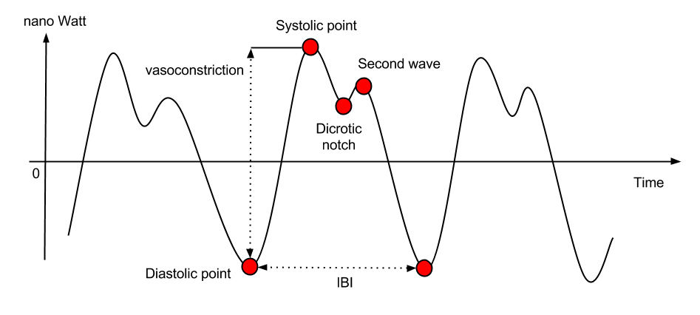

Figure - <https://support.empatica.com/hc/en-us/article_attachments/202917049/PPG2.png>

A plethysmogram (PPG) is a signal that measures the volume of blood traveling through a given part of the body. When a person’s heart beats the volume of blood changes as blood is pumped through the body creating a pseudo periodic signal. There are two phases of the cardiac cycle: the diastole phase and systole phase. The diastole phase is a period of low pressure when the blood flows into the heart. These low pressure points correspond to the local minima of the PPG signal (diastolic point and dicrotic notch shown in Figure 1). The systole phase is a period of high pressure when the blood flows out of the heart. These high pressure points correspond to the local maxima of the PPG signal (systolic point and second wave shown in Figure 1). The inter-beat interval (IBI) is used to calculate the pulse rate.

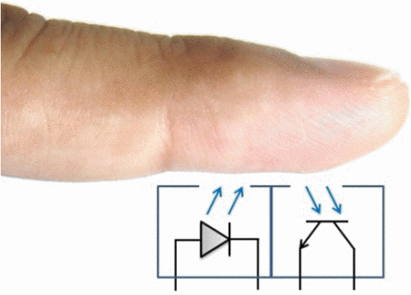

Figure - https://ieeexplore.ieee.org/ielx7/7036195/7042935/7043525/html/img/7043525-fig-1-large.gif

The PPG sensor that will be used in lab has an LED emitter and receiver to measure the volume of blood in the finger. Blood absorbs certain wavelengths of light, so the volume of blood in the finger corresponds to the amount of light reflected out of the finger.

# Data Collection

Since the PPG signal will be measured on a human, assumptions can be made about frequency of signal. Assuming that a human’s pulse rate will be between 30 and 300 beats per minute (BPM), calculate the cutoff frequencies for a band pass filter that will remove unwanted frequency components. Show all your work. Note: The creator of the PPG sensor already implemented an analog low pass filter so don’t worry about filtering the signal yet.

Again, using the assumption that the maximum pulse rate is 300 BPM, what would be the minimum sampling rate required to accurately calculate one’s pulse rate? Show all your work.

Now collect data from the PPG sensor using a sample rate of 100 Hz so that you can clearly see the different characteristics of the signal. Be sure to stand still when collecting the data. Note: Everyone’s PPG signal looks different so don’t worry about making the signal look exactly like Figure 1, but do make sure that the signal is periodic.

# Pulse Rule Calculation

Once you’ve collected a clean PPG signal, import the data into MATLAB. Calculate and plot the Fourier transform (FT) to view the signal’s frequenscy spectrum using the fft function. Remember that the FT calculates a complex number, so use abs to get the magnitude of signal. Why is the fft symmetrical? Plot only the first half of the fft and include it in your report. Be sure to calculate the frequency on the x-axis.

Now calculate the pulse rate by finding the frequency that contains the most energy. Hint: use $[\sim , maxIndex] = max(Y)$ where $maxIndex$ is the index at which $Y$ has the max value. What is the calculated pulse rate? Is this correct?

Remove the DC component from the fft by setting $Y(1) = 0$ where $Y$ is the FT of the PPG signal. Calculate the pulse rate again. Is it correct now? sd

**Be sure to include all MATLAB code used as well as the answers to all the above questions in your report.**